# Question 01

## A)

False

## B)

False

# Question 02

## Code

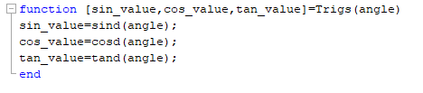

## Output

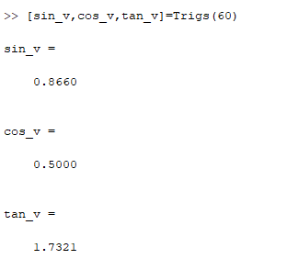

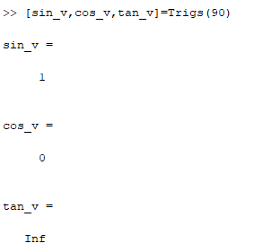

# Question 03

## Code

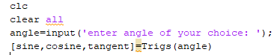

## Output

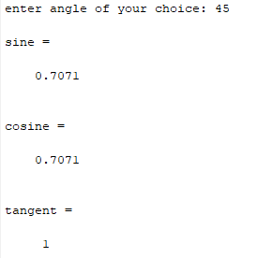

# Extra Credit

## Code

### A)

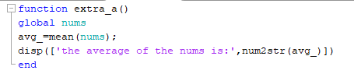

### B)

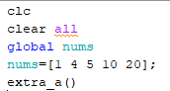

## Output

## 